# Executive Summary

Business management is the management of the organization's essential roles in order to achieve the company's goals. Management is the process of planning, organising, staffing, directing, and managing an organization's activities. It is considered as an significant term that is an essential component in the development and accomplishment journey of the company's goals. The major goal identified for the respective report is driving and analysing the business management objectives in terms of a simulation activity. The research focused on a number of crucial criteria, including the selected company's key performance metrics and product development efforts. The study draws conclusions based on the current state of the Sneakers Hub, which is expected to function in the financial year 2030. The major purpose of the business simulation activity is stabilising the requirement for business development for calculating the overall performance of the company.

Because the data was chosen to represent factual analysis, qualitative methodologies were used in the study. Because it aids in the execution of legitimate sources for the study, the research relies on secondary data collecting. According to the findings of the study, financial statements play an essential part in a company's ability to maintain a competitive market position. According to the findings, the business needs numerous critical strategies to operate in a competitive environment and significant investments in research and development to maintain product quality.

Keywords- Sneakers Hub, sneakers, simulation, product, research, and development.

Table of Contents

Executive Summary 9

Chapter 1 13

1 Introduction 13

1.1 Background 13

1.2 Aim 14

1.3 Objectives 14

1.4 Research Questions 14

1.5 Justification for the name and logo of the company 16

1.6 Details of the Team 16

1.7 Major achievement of the company 17

1.8 Role in the Team 17

1.9 Problem Statement 18

1.10 Outline the scope of the report 18

1.11 Report Structure 19

**1.11.1** **Introduction** 19

**1.11.2** **Methodology** 19

**1.11.3** **Findings and Discussion** 19

**1.11.4** **Conclusion and Recommendations** 20

Chapter 2 21

2 Methodology 21

2.1 Introduction 21

2.2 Research objectives 21

2.3 Research method 21

2.4 Data collection 22

2.5 Data analysis 22

2.6 Reliability and validity of research 23

2.7 Research limitations 23

2.8 Distribution and Inventory 23

Chapter 3 24

3 Findings and Discussion 24

3.1 Introduction 24

3.2 Strategies 24

3.3 HRM 24

3.4 SWOT Analysis 27

3.5 Porter Five Factors 29

3.6 Purchasing 31

3.7 Competition 34

3.8 Market Choice 35

3.9 Marketing 35

3.10 Finance 38

3.11 Distribution 42

3.12 Market Penetration 43

3.13 Key performance indicators 45

3.14 Retained profit as a percentage of net turnover: 46

3.15 Sales and demand for men, women and kids: 47

3.16 Market leader in price segment: 48

3.17 The educational level of staff: 49

3.18 The average stock limit in days: 49

3.19 Motivation staff: 50

3.20 Cost-benefit analysis 51

3.21 Financial Expenses of Sneakers hub 52

3.22 Discussion 53

3.23 Professional development 54

Chapter 4 57

4 Conclusion 57

Chapter 5 59

5 Recommendations 59

6 References 61

**List Of Figures**

**Figure 1 Product Segmentation** 17

**Figure 2 Innovation and Development** 17

**Figure 3** **Graphical representation of the workforce** 28

**Figure 4 Porter Five Forces** 31

**Figure 5 Product inventory** 34

**Figure 6 Purchasing** 35

**Figure 7 Ranking Of the Sneaker Hub Company** 36

**Figure 8 Sneakers hub company Market Segment** 37

**Figure 9 Market share** 38

**Figure 10 Company’s Product Price In Different Segment** 39

**Figure 11 Company chose intensive distribution** 40

**Figure 12 Balance Sheet Of the Company In year 2030** 41

**Figure 13 Income Statement Of the Company in 2030** 42

**Figure 14 Cash Flow Statement Of the company** 43

**Figure 15 Inventory** 44

**Figure 16 Sneaker Use Market Penetration Strategy** 45

**Figure 17 Market Demand** 46

**Figure 18 Key Performance Indicator** 47

**Figure 19 Table of achieved net profit** 48

**Figure 20 Graphical of achieved net profit** 48

**Figure 21 Table of Sales and Demand** 49

**Figure 22 Graphical of Sales and Demand** 49

**Figure 23 Table of Market Leader in Price Segment** 50

**Figure 24 Graphical of Market Leader in Price Segment** 50

**Figure 25** **Table of average stock limit in days** 51

**Figure 26** **Graphical of average stock limit in days** 52

**Figure 27** **Table of Motivation staff** 52

**Figure 28** **Graphical of Motivation staff** 53

**Figure** **29** **Table of Financial Expenses** 54

**Figure 30 Graphical of Financial Expenses** 54

# Chapter 1

# Introduction

## **Background**

In the research study, a business simulation activity was used to give an analysis of Sneakers Hub's operations. Sneakers Hub specializes to men, women, and kids. Sneakers Hub focuses on providing good product quality at a reasonable price. This investigation focuses on the business simulation in a real-world setting for processes that help managers over time in an organisation or corporation. It is referred as a real-time scenarios that is successfully describing the functionality and operations of business activities in a company. A method to identify the strategies of an organization's business procedure is referred as business simulation. The simulation report benefits the corporation by giving effective business control options (Oakland, 2014). The research covers all aspects of corporate operations, including company strategy, cost management, quality control, and other commercial activities. It is also beneficial for the company executives to support them. Sneakers Hub wants to expand its commercial activities from one country to another, and the research study below will help the company achieve this goal.

The business simulation practise approach provides leading advantages for the organisation by utilising the leading design and highest quality for efficiently executing business operations. The simulation process includes all aspects of business operations and leads to the company's market development in terms of quality and customer satisfaction. The business simulation process supports organisations in making suitable business decisions by giving strategic options for every sector of the business. It also benefits the organisation by allowing it to lead a more powerful and effective corporate vision. The business simulation process provides information about the company's business plan and leadership decisions. Sneakers Hub's business activities are investigated in the business simulation research. Internal and external business analysis gives information on efficient operations that aids the company's future expansion (Reyes, et al., 2017).

## **Aim**

The major purpose of conducting the respective report is increasing the overall understanding of business and calculating the throughout performance of the Sneakers Hub's Company through simulation activity.

## **Objectives**

* To examine the existing information available for the Business simulation Project and accordingly designing the marketing or business strategies.
* To identify the major issues and challenges concerning the simulation project and to develop effective solutions for them.
* To manage the actions and tasks, examine the entire performance and analyse the simulation activities.

## **Research Questions**

Q.1 What were the major issues that were confronted during the re-launch of the Sneakers Hub Company?

Q.2 What elements have influenced the Sneakers Hub Company's growth?

**Company Name**: Sneaker’s hub

**Company slogan**: “Every steps matter”

**Company logo**:

**Focus of the project**

**Figure 1 Product Segmentation**

Our sneakers hub focus on price and quality for men, women and kids . Our team decided after the meeting with board members that customer are focussing on price with good quality so we have chosen this focus of the project for our simulation .

**Innovation**

**Figure 2 Innovation and Development**

Sneakers Hub new innovation released latest model of sneaker in 2022 ,there is a growth in development as per sales of the company , got focussed on customer engagement to be acquire .

## **Justification for the name and logo of the company**

The major perspective for the selection of the company’s name as Sneakers hub was developing and spreading the idea of the business in manufacturing and selling sneakers offered by the company with a new approach for enhancing the overall quality and price structure for its customers respectively. It was to create a feeling of trust in the market for the company and also to create the awareness of the brand in the market as the leader of sneakers market. It also was beneficial in attracting new customers and retaining old customers who have been shifted buying from other brands respectively.

## **Details of the Team**

There were numerous people working in various positions throughout the organisation, each with their own set of responsibilities. The CEO, Marketing Manager, HR Manager, Logistics Manager, and Finance Manager were all regarded pillars of the organisation. These positions all have a department head who oversees a team and a variety of tasks. The CEO serves as the company's leader, ensuring that the team stays on course to complete the mission. On behalf of the company, the CEO primarily communicates with government units, the general public, and stakeholders. The company's vision and mission can be created and changed by the Chief Executive Officer for improving the company's overall performance. The marketing manager is essential for the success of a corporation. The marketing manager's primary responsibility is promoting a product, service, or brand and to oversee a variety of operations such as launches, email campaigns, social media, activities, events, and advertising.

The HR manager is in charge of all employee issues as well as operations like recruitment, role designing, talent management, performance management, training and development and employee relations. The HR manager's key responsibilities include selection and recruitment, compensation, HR data and analytics, and human resource system information. The logistics manager was in charge of the following tasks: Inventory, supply chain, warehousing, and transportation activities are all examples of logistics operations that need to be coordinated, monitored, and planned. The Logistics Manager's strong leadership skills and organisational abilities aid in the project's successful completion. Financial managers are in charge of an organization's financial health. They also perform other tasks such as straight investing actions, developing tactics or approaches, and producing economic reports for the organization's long-term financial goals. The financial manager assists the organization's management in making financial choices.

## **Major achievement of the company**

In compared to other companies, the company has achieved various milestones, such as ranking fifth. The total score for Sneakers Hub Company is 2,968,585. In comparison to other companies, the company gives high-quality products at reasonable pricing. The company uses intensive distribution for its products, which helps to ensure that they are available in as many stores as possible. The company has 57.29 percent employees who are well-educated and enthusiastic about their jobs. The demand for the Sneakers Hub Company's items has increased, as has the speed with which the products are distributed to sellers so that they may make better sales and profit. These are the accomplishments of the Sneakers Hub Company, which have aided in the company's growth.

## **Role in the Team**

As the head managers of the departments, there are various pillars of the organisation, and my position was one of them. In order to fulfil the tasks of this team, I am playing the function of Operation Manager in the organisation. My team and I were in charge of planning, monitoring, and coordinating logistic operations. The logistic department was in charge of activities such as inventory, warehousing, supply chain, and transportation. To organise the distribution and storage of items, the operation manager is sometimes known as the distribution manager. I gave confirmation that the merchandise would be delivered on time to the correct place. Stock control, transportation, warehousing and observing the flow of commodities are all part of the department's responsibilities. Advance thinking, strong analytical and numerical abilities, attention to detail, adaptability, accountability, and broad industry knowledge are some of the attributes that a logistic manager should possess.

## **Problem Statement**

The company's issues are the result of management and execution flaws. In re-establishing the company in several parts, the Sneakers Hub Company ran into a number of issues. Due to a lack of financial resources, the company had financial troubles or problems. Because of the restricted warehouse capacity to keep the products, the company also had warehousing issues. Another issue was the pricing of the product, as the Sneakers Hub Company's items were more expensive than those of other companies. The other competing company offered low product pricing to clients, causing this company to have a cost concern. Another issue was the employee's level of education; the company's goal was to have 77 percent educated personnel, but they only got 57.29 percent, which is preventing them from meeting their goals. Customers' reviews of the women's sneakers were not excellent enough to compete in the market with other companies that have good quality and reviews. The corporation lacked sufficient variations of children's footwear, which resulted in a problem in which customer relations became skewed.

## **Outline the scope of the report**

The following report's main scope includes an analysis of the impact and outcome of the company's strategies for resolving its challenges associated with changing consumer demand, limited financial resources available, a shift in consumer buying patterns, an ineffective marketing approach, and consumer disengagement, among other things. The corporation developed and implemented multiple strategies to address these difficulties in future performance that were related with various segments of the business. The scope of the strategies was viewed as critical in determining the advantages from a future perspective.

## **Report Structure**

The report's basic structure comprises information about the sequence of events that occurred throughout the study's execution. In this section of the introduction chapter, the study design is extensively detailed. This portion of the report lays out all of the steps that go into performing a successful study. The following is the research framework for studying the business simulation process:

### **Introduction**

This section of the report is delving into all the major steps that are involved during the overall business simulation activity procedure. It is providing an overview of the major goals and objectives that were set for the company in helping to better its business strategy in the market. The introduction chapter of the report demonstrates the overall understanding of business relations and employee relations in terms of the operations of the sneaker’s hub company. The main theme of the project has also been outlined in this section of the report.

### **Methodology**

The methodology is considered to be a significant chapter in the report that is solely focused on the simulation part the methodology and all the research objectives that have been selected and employed in the report are comprised in this section. Research method, Data Collection approach, Research Design, ethical consideration, and the reliability and validity considerations of the research are the five sub-points of this chapter. This chapter will be explaining all the approaches and methodology adopted in the report and also with its proper justification. It is implying that the important information of research has been collected and analyse with the use of a single approach (Islam, et al., 2021).

### **Findings and Discussion**

Findings and discussion section of the report will be comprising the important findings that have been derived from the analysis of information gathered in the report. It will also be providing essential information concerning the growth and financial performance of the sneaker’s hub company respectively. The balance sheet results will be also represented in terms of the financial games of the company in the year 2030. For meeting all of the project's requirements, the company paid a total amount of €6,018,143.41. as per the analyses of the income statement, the company's revenue net sales in 2030 were recorded to be € 5,672,438.00, whereas the cost of sale was recorded to be €3,861,648.07 for the company, this signifies that the company is experiencing substantial organisational growth. The information gathered with the application of the mono technique of research is likewise mentioned in this segment of the findings. It is also referred to as information on the company's cash flow statement, that is displaying its assets information (Munny, et al., 2019).

### **Conclusion and Recommendations**

The conclusion chapter in the report will be containing all of the findings as well as a discussion of the methodology chapter. This is the last level of the research study's framework, and it emphasises the significance of strengthening Sneakers Hub's commercial activities. According to this chapter, the organisation can get exceptional results within a certain time limit by following the relevant guidelines and ideas. This chapter will be also discussing the professional guidelines that required to be followed for business simulation practise, such as how to effectively perform work ethics.

# Chapter 2

# Methodology

## **Introduction**

Various approaches are used in this chapter of the research study to perform the investigation successfully and appropriately using these instruments and methodologies. Research objectives have been set, and secondary data has been employed to acquire data in research methods. The data was analysed using the qualitative method in this study. The ethics, dependability, and validity of the research are all addressed in the research methods section.

## **Research objectives**

* To study the data in order to build marketing and business strategies for the simulation project's management.
* To identify the primary issues and obstacles related with the simulation project and to develop solutions for them.
* To manage the actions and tasks, examine the entire performance and analyse the simulation activities.
* To identify the company's threats and weaknesses and make recommendations for improved performance, Based on learning and discovery.

## **Research method**

The research technique outlines the procedures and methods that must be followed for the study to be successful. The research method is determined by the study's approach. To perform the study, the research method is utilised to collect data from the simulation portal and then analyse the data to arrive at the desired output. Quantitative and qualitative research methodology are the two types of data collection methods considered in the research process. This study employs the qualitative research method because it investigates the problems that come with re-establishing a corporation in a new market. In the collecting and analysis of statistical data, the qualitative research approach is applied. The data for the study was gathered using a qualitative research approach that included observation, investigation, and evaluation. The data for the study comes from the simulation site, which includes details on the company's marketing, human resources, and product development processes.

## **Data collection**

To generate an effective and relevant solution to the study questions, data collection activities are used. We have generated the data from our simulation project such as from income, cash flow, balance sheet ,sales, finance ,marketing .Primary and secondary data gathering methods are two types of data collection procedures that are utilised to perform successful and effective research investigations. Secondary sources are the technique of data collection in this study (Trinh, 2018). This approach of obtaining information from a secondary source is utilised to obtain benefit in collecting information for the research study's objectives and goals. Secondary data is crucial for gathering information from the study's secondary sources. PDF journal articles, business forecasting process data, and annual statements of the shoe firms were used as secondary sources for data collection in the research study. By obtaining information relating to the research issue, this data gathering strategy aids in the simplification of the research study's objectives. Secondary data collecting is important in achieving the research study's objectives and goals, especially given the study's topic. The research study strategy has been used in the following study because it is a suitable way for exploring the phenomenon in a real-life example. This strategy aids in the formulation of a hypothesis for subsequent investigation.

## **Data analysis**

Data analysis methods are important in delivering an effective evaluation that is used for research in leading to a conclusion and achieving the study's goal. Secondary data was gathered using the simulation module, Microsoft excel,PDFs, and journal articles. For valuing the word-based data received from the simulation module, the content analysis method was used. This kind of data analysis is helpful in achieving a thorough study evaluation. Qualitative research use a variety of tools and approaches, such as secondary source data, to ensure a successful and efficient study. The study's goal can be achieved by using an appropriate content analysis approach to analyse the study's qualitative data (Malhotra, et al., 2017).

## **Reliability and validity of research**

In research investigations, reliability and validity indicate that the subsequent research will be conducted using all reliable and valid sources. The study's validity and authenticity have been confirmed, which improves the study's relevance in the future. The investigation was conducted without the use of obsolete data. Authentic research journals, papers, and articles were used as sources of information in the study. The following compiled research information contains information about numerous writers and their findings. A thorough schedule was also used to ensure that the research study was genuine and dependable.

## **Research limitations**

The drawbacks revealed in the research study while doing the inquiry are referred to as research limitations. The approach of picking the appropriate procedure for the specific research study is time-consuming, which slows down the research process. Because the research is based on secondary data, it only provides limited understanding about the subject of investigation. Furthermore, due to the limited supply of information, the study's scope has been reduced. One of the most significant difficulties encountered during the investigation was the lack of useful and relevant information. The data collection approach took a long time, making the study process laborious and constrained.

## **Distribution and Inventory**

We initially chose LTC as a transportation firm distribution cost was €4 and it takes 4 weeks to deliver the merchandise. As per the first year our sales increases so much so we have chosen the quickest delivery distribution company which cost high and deliver 0 week ETA for delivering the all products. We upgraded our warehouse to stock up the shoes

# Chapter 3

# Findings and Discussion

## **Introduction**

This section contains findings from many sections as well as a discussion of the study. Strategies, Competition, Market, HR, Key Performance Indicators, Product Development, SWOT analysis, Cost-benefit analysis, financial analysis, Porter, Management, Purchasing, and Data Interpretation were the variables on which the findings described the reference to the organisation. The conversation was based on the entire report as well as the questionnaire. This section displays the company's results and outcomes, analysing each factor and sector to understand the company's current situation (Turban, et al., 2018).

## **Strategies**

The company adopted a Market Penetration approach in order to improve its market reputation. The scenarios were created concerning the market and product of the company; the first scenario comprised launching a new product into an existing market. The second scenario involved introducing an existing product into a new market. To maintain a customer base for an existing product in an existing market was the third situation. The strategies were developed with these three scenarios in mind. Three separate scenarios required different strategies. Product development, diversification, penetration, and market development were also incorporated into the strategy. The Sneakers Hub Company developed a market penetration strategy that took into account a variety of criteria in order to reach their growth goals and objectives (Mal, et al., 2019).

## **HRM**

HRM, or Human Resources Management, was utilised to manage the company's departing employees, newly hired employees, and department leaders. The HR department at the Sneakers Hub Company works hard to hire nice, competent, and helpful employees because they are critical to the company's success. This company's HR department motivates, challenges, and educates all employees in order to keep them motivated and involved in their work. The company was always engaged in job fairs and organising events in order to hire qualified staff.

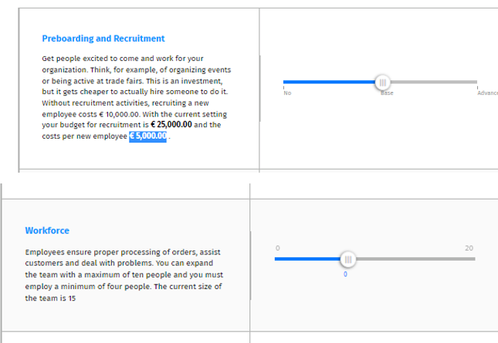

As Per the Above Figure, the company's recruitment budget for this cause was €25,000.00, with the cost of employing a new employee coming in at €5,000.00. HR evaluates the maximum workload per employee; if the maximum limits are exceeded, HR hires a freelancer to assist HR in restoring the workload to its previous level. At the moment, there are 15 workers working at the headquarters, who are in charge of orders, shipping, and client complaints. According to the task and budget, HR can grow the team by only 4-10 employees per year. HR's key goal was to hire experienced and educated personnel and to constantly motivate and push them so that they did not become demotivated (Otenko and Parkhomenko, 2019).

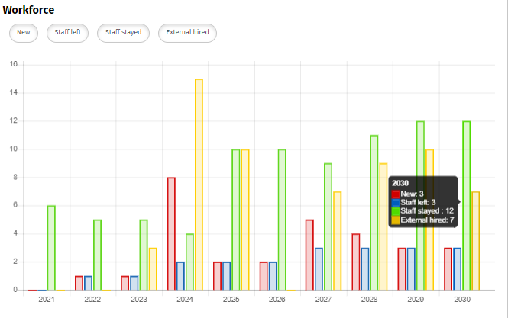

**Figure 3** **Graphical representation of the workforce**

New Staff, Staff Left, Staff Stayed, and External Hired were the four groups that made up the workforce. This graph depicts the number of new employees hired, the number of employees who left the company, the number of employees who stayed with the company, and the number of employees who were hired externally. The graph above depicts the data for each year's personnel. In the year 2024, the newest employees were hired; this year, there are eight new employees. In 2024, the maximum external staff of around 15 employees will be hired. There was a time in 2030 when the company's maximum number of employees was three. In the year 2030, the number of stayed employees reached a maximum of 12 people. In 2030, the workload on the company increased due to the departure of 3 employees from the company. For which the company hired 7 external freelancers, which reduced the workload on the company's employees.

## **SWOT Analysis**

|  |  |  |
| --- | --- | --- |
| **External** | **Opportunities** | **Threats** |
| * Sneakers hub achieving excellent results without spending a lot of money. It is because of the strategies adopted by company for manufacturing a product in a more efficient manner for saving money. Businesses are examining the ratio of product produced for costs incurred for determining cost-efficiency. * Sneakers hub is investing more in promoting its online sale. Sneakers hub was demonstrating and establish competence through online marketing in a variety of methods. The company used online marketing to more efficiently establish and build relationships. * strategist is overlooking the market's perceived segment distinctions and utilising a marketing plan that is focused for attracting huge customers, this is considered as indiscriminate targeting. | * There was a big risk in front of the Sneakers hub concerning the product prices that the company's competitors are using for selling similar products at a lower rate. * Threat of new entrants with similar products might pose a severe threat om the functioning of the Sneakers hub and may also hamper the market position of the company. * Economic instability might also pose a range of negative consequences for several businesses operating worldwide in which economic assets lose value and investment is hampered or stopped. * After Pandemic the sales and revenue generation of the company badly impacted with change in consumer preferences. * Product replica existing in the market severe threats. * Sneakers hub is not concentrating on developing and promoting its items in other market segments. |
| **Internal** | **Strengths** | **Weaknesses** |
| * Customers benefit from effective distribution since it offers them with convenience in the form of availability. * The research and development team of the company was well-trained and skilled. * Sneakers hub on all markets must meet rapidly changed customer demands by delivered products quickly and efficiently (Ibrahim, et al., 2019). * Cost Leadership strategy was adopted by the company. To promote the availability of capital resources, cost leadership is critical.. | * The corporation had limited financial resources, which caused challenges with budget control. * The company's weakness is its reliance on third-party producers. * The company's promotional powers in sales and marketing are limited. * Contract manufacturers are under the company's control to a limited extent. |

## **Porter Five Factors**

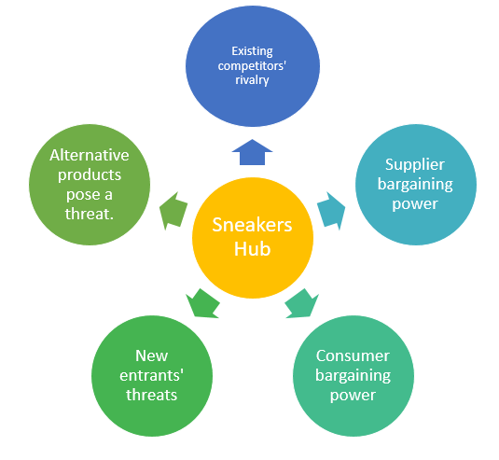

**Figure 4 Porter Five Forces**

|  |  |  |
| --- | --- | --- |
| Factors | Description | Impact |
| 1. New entrants’ threats | Newcomers to the footwear business brought with them innovative ideas and technological advancements that benefited the production process. New competitors represent a significant threat to the company's competitive advantages. It is also putting a lot of pressure on the Sneakers Hub Company's operations, causing them to reduce their pricing and spend less money. It allowed the corporation to offer new rates to its customers. As a result, the corporation adopted aggressive measures to preserve a competitive advantage in the market. | **Low** |
| 1. Powers of the supplier | The footwear industry had a large number of suppliers, and because of its authoritarian nature, they had a bargaining advantage and could demand higher pricing. Suppliers' aggressive negotiation techniques hurt the company's overall profits. Through creative product designs and additional items, the company was able to deal with these supplier negotiation capabilities (Ishmael, 2019). | **High** |
| 1. Buyer power | Customers are frequently looking for good deals at reasonable prices. The earnings of Sneakers Hub Company have decreased over time as a result of the difficulties in communicating with customers. Growing the company's client base was a successful approach for lowering customer bargaining power while simultaneously expanding sales and manufacturing operations. | **High** |
| 1. Threat of substitution | Substitution items posed a threat to the company's profitability. Sneakers Hub Company was able to lessen the risk of product replacement by moving its focus from products to services. Customers' preferences and desires were valued more than the products they purchased. In addition to what they were buying, the company wanted to know the customer's preferences. As a result of the high brand loyalty in the market, the threat of substitute items has been observed to be reduced (Mina, et al., 2020). | **Low** |
| 1. Competitive rivalry | The market's fierce competitive competition was the firm's biggest challenge. Because a huge number of competitors supplied the same products and services, the company's demand was lowered. The Sneakers Hub Company works in a highly competitive footwear market with a large number of competitors, and this fierce competition has harmed the company's overall growth and profitability. However, the organisation has been able to achieve a promising position thanks to smart decision-making. | **High** |

## **Purchasing**

The purchasing department is enabling the corporation in growing its warehouse, selecting different suppliers, and imposing order management restrictions.

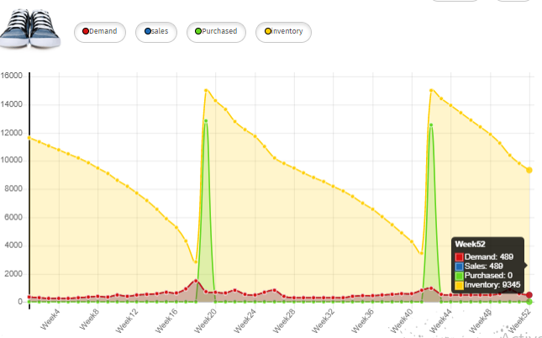

**Figure 5 Product inventory**

In the first week, the company had a stock of 11667 men's shoes in Purchasing, from which the demand for the product was 333, sales were 333, and the total purchase of the goods was 0. Demand for the goods came in at 489 out of 11000 in the last week of 2030, and 489 companies sold the product (Risso, 2018). The company's inventory of children's sneakers was retained at 4536 as a result of this, of which 718 were in demand and 718 were sold. The year is 2030, and it is the last week of the year. In the first week, the company purchased 15000 pairs of women's sneakers, of which only 415 were in demand, 415 were sold, and the total product buy quantity was 13883. The company had lowered the inventory of women's sneakers to 2912 last week, but after receiving a demand of 795, it boosted the inventory of the new product and completed the transaction.

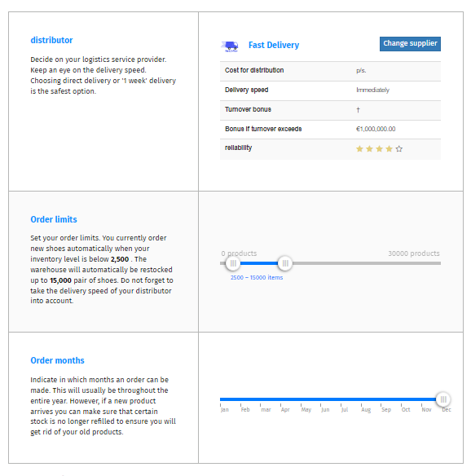

**Figure 6 Purchasing**

To optimise product delivery, the organisation used a logistics service provider. The service provider is required to be making sure that the delivery cost for the product is affordable to their target customer; as a result, the company has identified that direct delivery of the product and one-week delivery are the most safest and appropriate options available, and that by using them, the company was able in maintaining its delivery speed. To overcome its storage problem, the corporation has appointed an order restriction. If the inventory level for a customer's product order is less than 2500, the inventory will automatically be changed to 15000. When the company introduced new products in market, it started keeping the stock of the new product lower so that sales of the old product do not have to suffer. As a result, the company has significantly enhanced its product sales and successfully meeting client demand by providing quick delivery (Phan, 2020).

## **Competition**

As compared to other sneaker firms, the Sneakers Hub Company is ranked fifth. WALKWAY, HAWKS, LEO FEET, VALENCIA, and SOLEMATES were some of the company's primary competitors. These companies outperform the VALENCIA Company in terms of quality and pricing, and they also have a strong consumer base. Some firms compete with Sneakers Hub, such as VALENCIA, FEATHERS, and INSOLES, but they are not as good as Sneakers Hub. Quality, cost, services and customer support and base were the elements that companies competed on. Companies compete in the market based on such variables, earning good names and rankings in the process. In comparison to WALKWAY, the quality of Sneakers Hub Company was lower. The company's total score was 2,968,585, which was lower than the other three corporations (Glaister, et al., 2018).

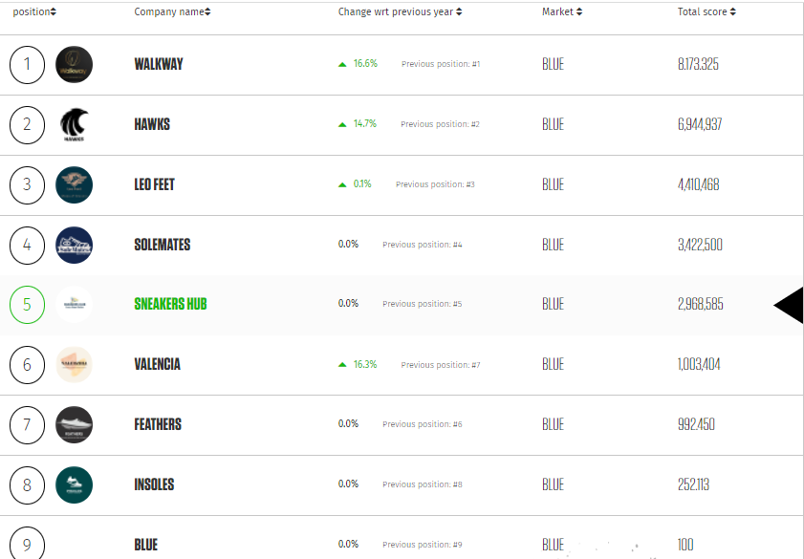

**Figure 7 Ranking Of the Sneaker Hub Company**

## **Market Choice**

The company sells men's, women's, and children's products in the market. Based on market knowledge, there were primarily three segments of clients. The first section consisted of people who purchased sneakers only on the basis of pricing. This segment's customer buys low-cost sneakers because of the brand, not because of the quality. The customer in this group is brand loyal or prefers branded sneakers of the highest quality. This segment's customers aren't as concerned with the product's rice as they are with the brand. The final portion was all about improving customer interactions. This relationship was built on the basis of supplying high-quality products at reasonable costs, as well as products tailored to the preferences of clients. The third sector oversees the quality or features of the other two segments; it comprises branded products of high quality, as well as a wide selection of products suitable for all types of customers. The Sneakers Hub Company concentrates on the third part because it overlaps with the previous two. To build a solid link with clients, the organisation supplies a wide range of products based on quality, brand, and price (Wikhamn, 2019).

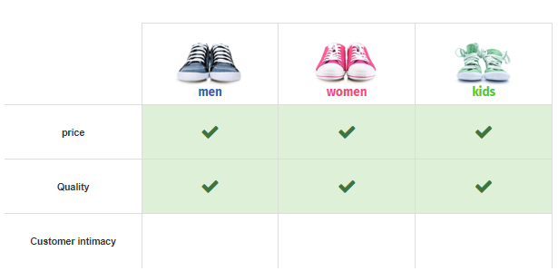

**Figure 8 Sneakers hub company Market Segment**

## **Marketing**

Marketing is the process of establishing a strong relationship with clients through the use of successful tools and tactics (Wani, 2013). The marketing portfolio of Sneakers Hub, as shown in the diagram, delivered market share for the company from 2022 to 2030.

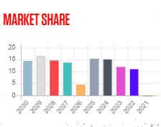

**Figure 9 Market share**

It can be shown that Sneakers Hub has acquired a small market segment in 2022, but the company has grown in the competitive market in 2030. The company had previously discussed the four Ps of marketing in relation to its product.

Product- The company's product has been designed to help the company grow by capturing a broad market segment (Tapp and Spotswood, 2013). To improve the quality of the product, the company has invested in research and development. The corporation had made agreements with the manufacturer to ensure that the product quality was maintained.

Price- The product's pricing has been kept low while the product's quality has been maintained. The pricing of the Sneakers Hub product has been kept at €48 to appeal to a wide range of clients. Because price plays such an important role in attracting the target market, the company has set the price segment to be reasonable in order to entice men, women, and children to purchase the sneakers (Chen, 2018).

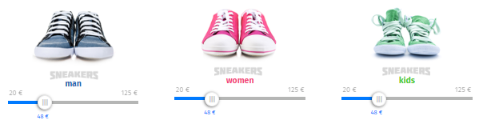

**Figure 10 Company’s Product Price In Different Segment**

Place- The location gives the company an idea on how to distribute its goods and target a certain segment of the local market. For the purpose of conducting the research, three market distribution segments were investigated. Intensive distribution, selective distribution, and exclusive distribution are the three marketing segments (Khan, 2014). In order to target the maximum number of sales in the market, the corporation used intensive distribution tactics by providing the scope of product distribution to numerous retailers. The chosen distribution strategy was chosen to help the company strengthen its position in the price market.

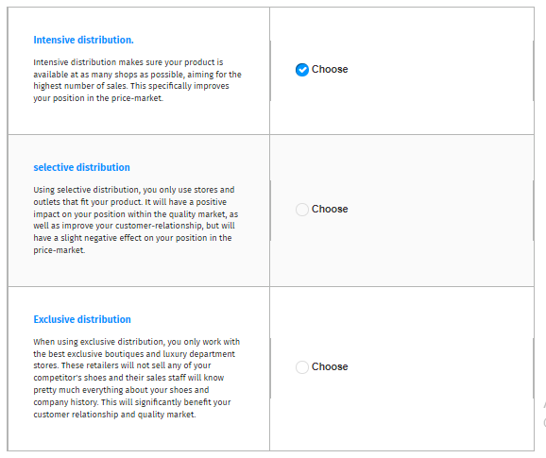

**Figure 11 Company chose intensive distribution**

Promotion- The promoting segment of the product in the market is determined by the marketing mix's promotion in the four P's. The Sneakers Hub utilises internet marketing as a promotion technique because the company has a website where it promotes its products and has used social media platforms such as Facebook, Twitter, Instagram, and others to reach out to a big youth market (Shams, 2013). For informing buyers about the brand, the company invested in SEO marketing and used a pay-per-click service. According to the above figure, the company's sales have been steadily increasing, indicating that the product is being promoted and the value of the sneakers is being built in the competitive market.

## **Finance**

This section contains the company's financial statement as well as information about the Sneakers Hub's current financial condition. The assets, liabilities, revenue, and expenses of the company were all covered in this segment. The following balance sheet contains information on the company's financial statement for the year 2030.

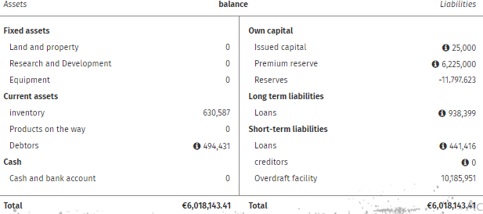

**Figure 12 Balance Sheet Of the Company In year 2030**

The balance sheet's assets and liabilities are in perfect balance, indicating the financial statement's strength (Boeckx, et al., 2017). It can be deduced that the corporation invests its funds in land and property in order to grow the company. The organisation has a minimum overdraft facility, which is a positive sign of Sneakers Hub's debt repayment. In order to keep the product's quality up to date, the company has spent in research and development.

Income statement

The financial statement of a company that represents the company's financial situation for a given accounting period is known as an income statement. Analysing the organization's income and expenses can be used to evaluate its financial performance.

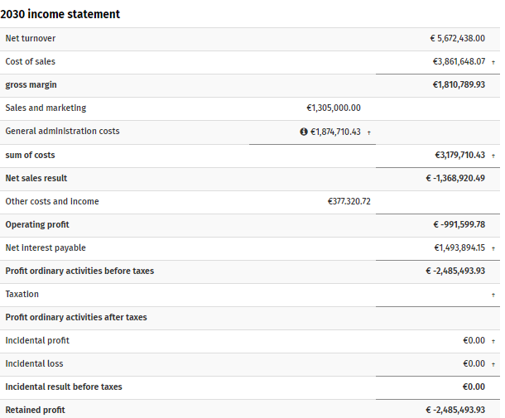

**Figure 13 Income Statement Of the Company in 2030**

According to the presented image, the company's net turnover profit is € 5,672,438.00 euros, with the profit on ordinary activities after taxes indicating a loss. The organisation had been in a deficit as a result of ignoring the financial statement of the Sneakers Hub, according to the analysis. The income statement is also useful for determining the difference between the organization's earnings and costs (Jagannath and Koller, 2013).

Cash flow statement

It was determined that the corporation was losing money, but the organisation also needs sufficient funds to maintain its operations.

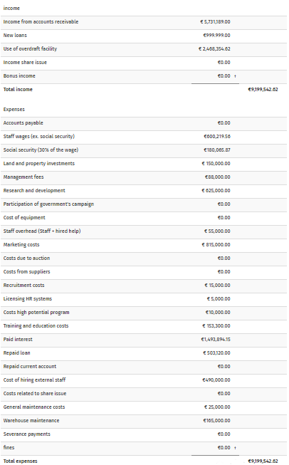

**Figure 14 Cash Flow Statement Of the company**

The figure depicted the organization's current cash flow statement and the appropriate method for analysing the cash flow statement. The company's entire income in 2030 was €9,199,542.62, but its expenses were €9,199,542.62, which were higher than the money earned. This has provided a summary of the organization's earnings and expenses, as well as the explanation for the company's financial division receiving insufficient attention. The fact that Sneakers Hub was ranked 5th in the rankings indicated that the company had good financial accounts. While analysing the findings, it can be deduced that the organisation should pay greater emphasis on the financial statement in order to preserve its competitive market position (Sayari and Mugan, 2013).

## **Distribution**

The corporation should do salesmanship thanks to distribution. It establishes a connection between the company and its customers. To ensure that the product and service reach the intended clients, the correct distribution method must be chosen (Dent and white, 2018). Intensive distribution was chosen as the company's marketing approach. Under this arrangement, the corporation is able to supply its products to small vendors as well as large retailers. It has offered the company the ability to raise product awareness as well as increase sales revenue through intense distribution. The business makes certain that its product is available to clients in as many locations as feasible. It also promotes the company's growth and improves its market position.

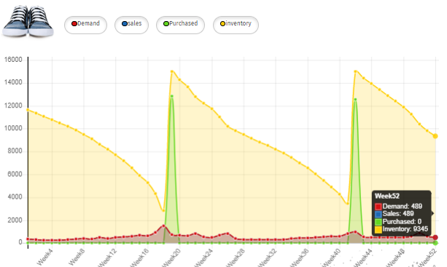

**Figure 15 Inventory**

The inventory of the company is depicted in the graph above. Demand is represented by red, sales are represented by blue, purchases are represented by green, and inventory is represented by orange. This graph depicts the company's weekly analysis. An in-depth analysis of the number of shoes sold during the week, the stock available throughout the week, the company's purchases during the week, and the number of shoes in demand during the week.

## **Market Penetration**

A company's Market Penetration process is critical. The process of delivering a new or considerably upgraded product to clients is known as market penetration. The customer in this case could be both internal and external to the organisation. The Market Penetration process has also been implemented by Sneakers Hub.

**Figure 16 Sneaker Use Market Penetration Strategy**

The Market Penetration was done based on the research and development of the company. The administration of the Sneakers Hub is primarily concerned with research and development, which employs 0 people.

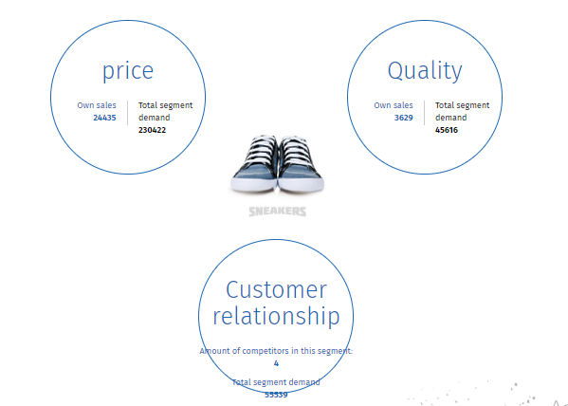

**Figure 17 Market Demand**

The three circles in the illustration depict how the corporation allocated research and development funds to improve the quality of their product. The first R&D circle reflects how effective the company was in the previous year's division. The total score of the firm was 95.71429, whereas the total score of all companies in this segment was 2,329.55, indicating that the sales company made inside the category was 24435. The second circle shows the product's quality. During the segment, there were ten competitors, and the total segment demand was 35616. The link between the corporation and its customers is represented by the third circle. During the segment, there were ten competitors, and the total segment demand was 55539. Machines were also installed in Sneakers Hub's office. Machinery has had a 50% impact on the Research and Development department. The company's machinery for making new sneakers is regularly modified, tested, and repaired. The company's first phase is product development. It is the company's most important instrument for staying afloat in a competitive market. It's critical to keep up with market trends and changes in order to capture broad customer groups. Market penetration will assist the company in achieving growth and success.

## **Key performance indicators**

The number of targets established by the organisation and the number of targets achieved by the enterprise are represented by the key performance indicators. The organisation set five objectives, one of which was met.

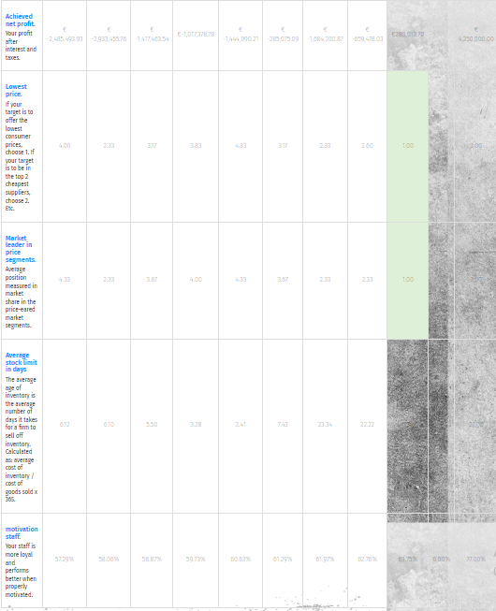

**Figure 18 Key Performance Indicator**

The Diagram depicts the company's 5 core objectives, as well as the main goal achieved through the Sneakers Hub:

## **Retained profit as a percentage of net turnover**:

**Figure 19 Table of achieved net profit**

**Figure 20 Graphical of achieved net profit**

The organisation established a net turnover goal of € 4,250,000.00, but only managed to reach € -2,485,493.93. The term "net turnover" is reffered to the annual sales volume minus the organization's cost, which includes sales tax and discounts. The net turnover is derived by multiplying the gross profit by the cost of products sold (Sagala, 2019). The company was unable to strive toward obtaining the percentage of net turnover ratio, despite the fact that it had become critical for the company due to bad financial statements, according to the analysis.

## **Sales and demand for men, women and kids:**

**Figure 21 Table of Sales and Demand**

**Figure 22 Graphical of Sales and Demand**

The data is obtained from simulation project and represented in the form of table and graph. The above graph shows the comparison between men, women and kids sneakers sales and demand trend. In Year 2022 both men and women sneakers were having the same sales whereas kid’s sneakers had 0 sales and demand. In the year 2023 sales of men and women sneakers went down and kid’s sneakers sold 13924. In the year 2024 all 3 categories had less sales compared to the previous years. Year 2026 registered the lowest number sales of men and women and year 2022 for kids. Highest number of sales in men, women and kids are registered in years 2022,2029 and 2028 respectively.

## **Market leader in price segment**:

**Figure 23 Table of Market Leader in Price Segment**

**Figure 24 Graphical of Market Leader in Price Segment**

The company was successful in meeting this KPI target because the organization's target was 3 percent, and by combining the years 2030 and 2022, the company met the entire 4.33 percent target. This indicates that the company has concentrated on the pricing sector, which has led to the realisation of the company's aim of providing a viable product to customers (Kumar and Chaturvedula, 2013). The money and price paid by the customer for each unique goods have been valued by the corporation. As a result, Sneakers Hub has become a market leader in the pricing range.

## **The educational level of staff**:

Sneakers Hub set a goal of achieving 77 percent educational levels among its employees by 2030, but only managed to attain 57.29 percent. The organisation has supplied employees with training in terms of job expertise and how they might improve the quality of their work (Amanchukwu, et al., 2015). It can be seen that in the year 2022, the organisation attained 63.75 percent, which indicates the population of educated workers in that year.

## **The average stock limit in days**:

**Figure 25** **Table of average stock limit in days**

**Figure 26** **Graphical of average stock limit in days**

This word refers to the number of days that a company's products have been on the market. It relates to the stock clearance in the organisation and the number of days it takes for the stock to be cleared from the company, as well as the company's feasible sales target. The organisation set a goal of clearing the company's shares in 30 days, but it only took 31.20 days to fulfil that goal.

## **Motivation staff**:

**Figure 27** **Table of Motivation staff**

**Figure 28** **Graphical of Motivation staff**

The corporation set a goal of 77 percent for employee motivation, but only got 57.29 percent. When employees are inspired to accomplish their work efficiently, this shows the staff's loyalty and motivation level.

## **Cost-benefit analysis**

The cost-benefit analysis is defined as the process of comparing expected and estimated project costs and finding which makes the most sense from a business standpoint (Pearce, 2016). The cost-benefit analysis is critical for evaluating a company's financial statement and identifying the organization's expenses and profits in terms of the product it sells. The organization's expenses were discovered to be €9,199,542.62 and its income was estimated to be €9,199,542.62, indicating that the corporation was in the red for the year 2030. The corporation had not invested in research and development, which resulted in a major failure in terms of meeting the Sneakers Hub's inventory management goal. The organisation has purchased warehouses and invested in land and property to store the product. However, it may be deduced that the organisation has approached a large number of distributors in order to meet the company's sales targets.

## **Financial Expenses of Sneakers hub**

**Figure** **29** **Table of Financial Expenses**

**Figure 30 Graphical of Financial Expenses**

In above Figure shows the Financial expense of sneakers hub , we have spent on loan repayment, interest paid , R&D expenditure . Each year in table shows that we paid loan repayment high. Sneaker hub took loan and overdraft we have spent on R&D for long term business.

## **Discussion**

According to the aforementioned data, Sneakers Hub is ranked fourth in the competitive ranking, and its product sneakers is the most valuable product in the company. Cost leadership is one of the organization's strategies that has been examined, as the corporation tries to provide the best and cheapest items to clients in the market (Trent and Cho, 2020). In order to achieve the major goal of supplying a practicable product to the client in a competitive market, the organisation reduces the cost of the product wherever it appears possible. It was determined that the organization's HRM strategy was robust because the corporation had set aside € 25,000.00 for the recruitment process in order to hire the requisite expertise. It has been discovered that the corporation spends € 5,000.00 on the hire of one employee. The company hired 15 people at its headquarters, who have aided the organisation in meeting its goal of individual employee growth. The organization's major purpose has been recognised as hiring talented employees. The corporation employed people from both internal and external sources, and it was determined that the organisation hired and managed individuals within the company (Drori and Honig, 2013).

The Sneakers Hub conducted a SWOT analysis to assess the organization's internal and external environments. The organization's competitive market status has been determined by evaluating the opportunity, threats, strengths, and weaknesses. The company's strengths, according to the SWOT analysis, include good quality and a reasonable pricing for the product. In comparison to its competitors, the company had offered the lowest pricing for its product. Limited financial resources were one of the key impediments to the organization's success, since the financial statement of the corporation reflects the company's low financial growth. The corporation has a small number of warehouses, which reflects inadequate stock management. Porter's five forces have also been examined, which indicate the new entrant's danger to the Sneakers Hub, and the risk organisation has been evaluated due to the buyers' negotiating power. Due to the entry of new competitors, demand for the company's products has decreased. New competitors have entered the market (Amir, et al., 2017). In the data analysis segment, the product inventory was also completed, which represented the total inventory in the warehouses and also supplied information about the company's sales.

The company has extended its store capacity by investing in warehouses, despite the fact that stock management in the company is little because unsold product remains in the organization's warehouses. Sneakers Hub has been discovered to have used a variety of distributors to improve the distribution route for men, women, and children's sneakers. The company's competitors have been discovered, and they include WALKWAY, HAWKS, and LEO FEET. The company is ranked 5th in the competitive market. Other organisations, such as VALENCIA, FEATHERS, and others, fall below the status of Sneakers Hub. The distributors were asked to evaluate the 4Ps sector of marketing, which includes price, place, promotion, and product. The financial analysis comprises the company's financial statement as well as the identification of key performance indicators (KPIs) (Marr, 2012). The company's cost, income, and expense have all been evaluated through product development and cost-benefit analysis. Personal development describes the discoveries discovered during the report-writing process.

## **Professional development**

Planning, organising, staffing, and controlling the business process in order to achieve the company's purpose is referred to as business management. Sneakers Hub is a re-established company that was founded as a result of a loss in the Sneaker's sales cycle. Because the organisation is built on shoes and develops an interest in shoe manufacturing enterprises, I chose the Sneakers Hub company. Another factor for choosing the company was that it is now ranked second among its competitors. During the simulation activity, I gained knowledge about the project by using the website's portal and analysing the company's market position using a SWOT analysis (Gatti, et al., 2019). The Sneakers Hub's assets, such as branding, management, worldwide strategies, and experience in research and development, increased my market analysis capability. The company's strengths aided me in honing my management abilities in organising data in order to identify the organization's primary research activities.

The Sneakers Hub company prepared a business strategy that assisted me in evaluating the company's results. In order to meet the price strategy target, we distinguished the company's product division. Our team has studied and differentiated one of the main market categories by designing the shoe category for men, women, and children. By analysing the organization's market, our team was able to determine the product's prices (Zulfiqar, et al., 2019). The product pricing of the shoe has been determined to be 48 euros, which is a reasonable price for customers to pay. We wanted to sell our Sneakers Hub sneakers to every retail store in the area so that we could reach out to the locals. We've tried SEO marketing, pay-per-click advertising, and other web marketing strategies. Marketing through newspapers, radio, television, magazines, flyers, billboards, and trade shows are among the offline promotion strategies we choose to advertise the brand.

I discovered that the Sneakers Hub's Sneakers comprise a distribution system, limited financial resources, and a gap in the organization's sportswear area. My team has put in a lot of effort to compute the Sneakers Hub's marketing and business plans because it has helped me evaluate the company's goal for reaching the company's future purpose. We've learned how to run a business, which has honed our management skills and prepared us to run firms in the future (Reynolds, 2017). Through branding strategies, I learnt to enhance my social skills and promotional skills, as well as how to promote the business through online marketing and approaching the traditional market. In order to build the business in a new sector and city, we used managerial talents. I discovered that by honing my management skills, I was able to build the ability to manage people. By completing data analysis and competitive market analysis, my team was able to boost research and development. By understanding the research findings in the report, we were able to develop sales.

My competitive skills, as well as my ability to stand out and represent the organisation in front of competitors, have improved as a result of the research. In order to conduct coordination exercises with my team, I learned to hone my communication and coordination skills. By increasing my involvement in team initiatives, my coordination and communication abilities will help me perform successfully in future projects. My financial abilities were lacking, but the report forced me to improve them by recognising crucial words in financial resources like net profit and revenue measurement.

# Chapter 4

# Conclusion

With regard to goal one, it is clear that Sneakers Hub Company experienced a number of difficulties. They conducted investigation into the issues and came up with a solution. To provide the greatest possible experience to their customers, the organisation realised that business to customer processes needed to be client centric. Due to the problems customers have in contacting the brand, many businesses struggle to earn client confidence. The firm then assists their customers by offering live chats in which they are able to ask inquiries and receive immediate responses from professionals. Customer service is also available 24 hours a day, seven days a week. Customers are welcome to contact at any time and ask any questions they have about their items. Problems with delivery, shipping, and refunds are among the company's other key issues. People will think twice about buying a product if the brand does not have a solid return policy. Customers were then drawn by the company's offer of discounts and the availability of cash on delivery in order to develop customer trust in their ability to pay once the product was delivered to them.

In terms of aim two, it has been determined that the organisation has employed some of the most effective tactics in order to improve its performance. The firm has adopted a cost-leadership strategy. The goal of the cost leadership approach is to provide high-quality items at an affordable price. To stay competitive in the market, the company has positioned itself as the cheapest manufacturer of sneakers in the eyes of buyers. With the findings of the Sneakers Hub project, several professional growth opportunities have been identified, according to the analysis of target three. Communication, interpersonal skill, decision-making skills, time management, and artificial learning are key elements learned from the research and findings of the project.

During the research and discoveries for objective four, it was discovered that Sneakers Hub had come across various risks and weaknesses. Excessive commercialization was one of the company's weaknesses; the shoe industry is so competitive that manufacturers try their hardest to commercialise their products. This tarnishes the image of the company. Due to a lack of sufficient understanding, a company tried to offer a slew of sporting products but failed to educate customers about the brand, proposal, and product categories available. As a result, the brand is solely connected with sneakers. Huge rivalry in the footwear sector was one of the risks the company faced. The company is now ranked 5th in the competition. It's challenging to stay in the race and compare their progress to that of their competitors. Duplicates of products are one of the biggest dangers to the footwear business. Companies who are on the cheap strive to imitate and operate duplicates in the market. As a result, the buyer is drawn in by the low price and purchases the knockoffs. It has been suggested that a corporation use advertising for sales promotion in order to protect the brand's goodwill. Before launching any project, a corporation should conduct thorough research and analysis of the target market, audience, and distribution method.

# Chapter 5

# Recommendations

**Focus on financial statements**- Because finance is the fundamental foundation of any industry, it is critical for the industry to concentrate on the financial statements. The financial statement depicts the industry's current competitive market position. The stronger the financial statements, the better the industry's prestige, which attracts more investors and allows the industry to represent the organisation on a global scale. Concentrating on financial accounts may aid in ensuring that the industry's operations function smoothly. More focus on finance might lead to better openness in the industry.

**Manage the inventory effectively**- Because a complicated inventory procedure might add further complexity to a company's working process, a simple approach for managing stock must be used to update inventory as demand changes. To keep stock, more warehouses should be built, and manufacturing should be based on consumer demand analysis. The stock clearance sale can be used to clear inventory while also developing a new product concept. Journals and ledgers must be kept to ease the inventory procedure in the industry.

**Investing in research and development operations**- By analysing the competitive market, it has become vital to focus on the R&D process in order to analyse actual client need and then frame the product to fulfil that want.The industry's research and development scenario must be built on present product execution and market investment in new and preferred designs. As it is making the product unique and identical for the befit of brand name, there must be a essential expenditure to be incurred in research and development development. By experimenting with the product, research and development also assists the industry to manage inventory and to improve the quality of the product.

**Focus on quality and customer intimacy**- Although a low price may entice customers, a product of bad quality or a product of poor quality can result in low sales and a negative brand image. To drive more customers to the company's purchase platform, the industry must focus on customer pleasure and intimacy. It is critical for the industry to comprehend the relevance of both quality and price in order to retain clients. Customers want a product that they can get at a reasonable price and that is of good quality.

**Invest in promotion**- Through a modern and classic promotional method, product marketing plays a vital role in attracting clients. For determining the strategy and information regarding the product to the target market, the industry is required have a long-term budget for marketing and promotional aspects. Investment in product promotion is not a waste of money, but rather an investment in the industry. As a result, the sector must commit to investing in product promotion and capturing the loyal customer market.